**Contents**

Introduction 1

What is SafeGaze? 1

How it works? 1

Livestreams 2

Setting up a livestream 2

Linking livestream to SafeGaze 2

Managing members 3

Requests 3

Active members 4

Inactive/Declined members 4

Facility information 5

Issuing messages 5

A few additional notes 6

# Introduction

## What is SafeGaze?

Welcome to SafeGaze; a web app that is directed towards the physical safety and cybersecurity of sports clubs and facilities. It focusses on providing a safe streaming platform for a facility’s members, and thus negates the risk of stalking or harassment of strangers and its members, especially when the participants primarily consist of children. By implementing this system, facilities will be able to create a secure livestreaming platform which allows their members to safely watch their children taking part in such activities.

**Photo/video of sport footage**

## How it works?

Facilities will be able to control which members have a SafeGaze account that is linked to said facility, alongside with what times each specific user has access to these livestreams.

This application is split into two separate systems: one for the facility, and the other for the facility’s members, each of which can be access through their respected login pages, where facility sections are colour coded blue, whilst member sections are green.

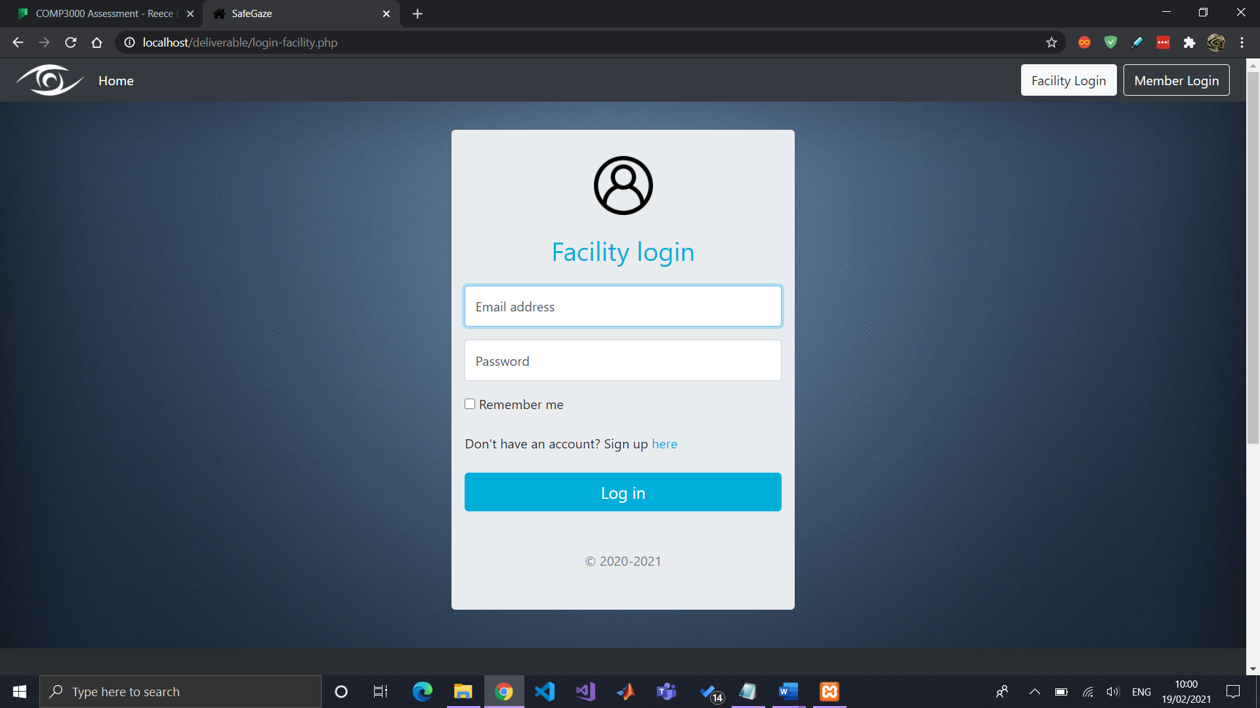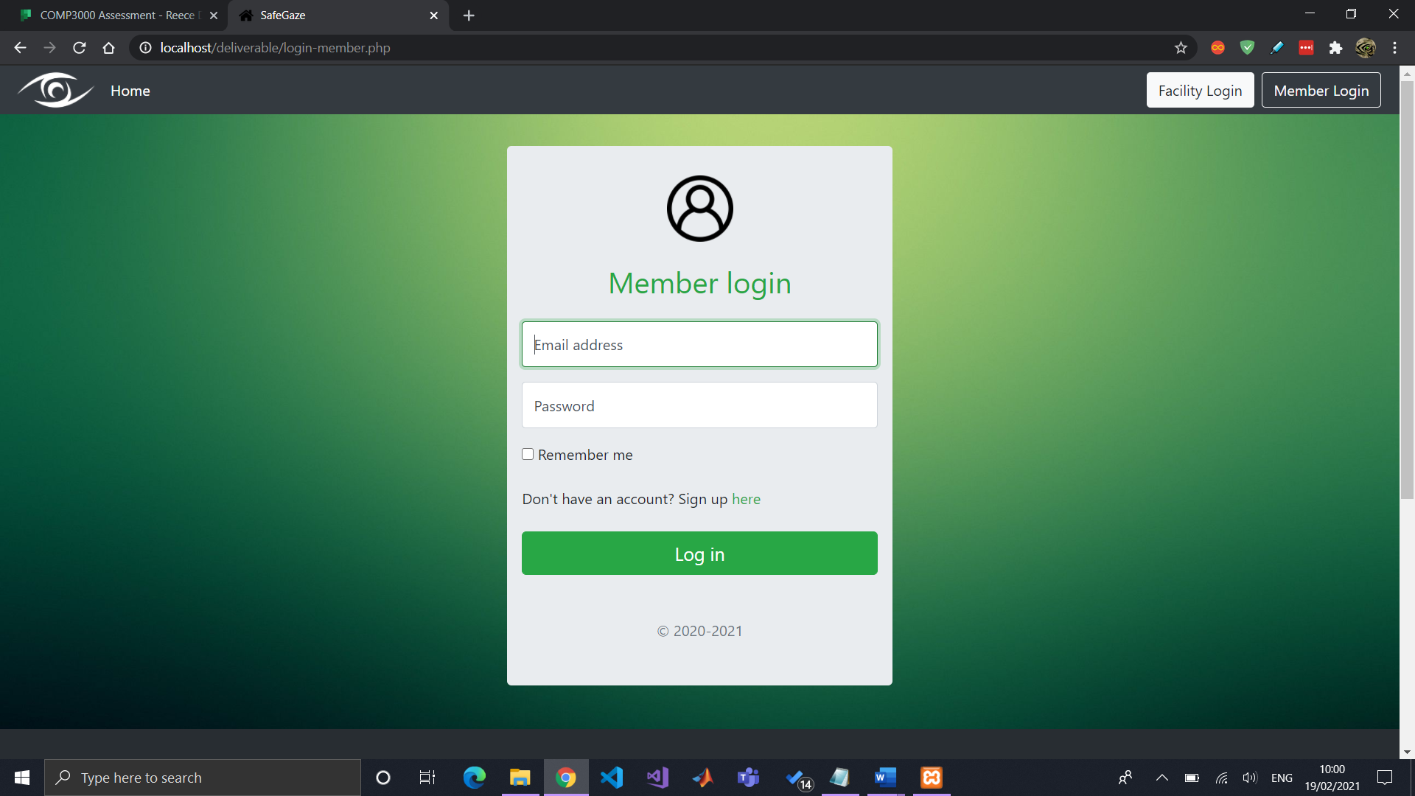

# Livestreams

## Setting up a livestream

As of the moment, SafeGaze makes use of YouTube livestreams “as a proof of concept”, as private stream hosting platforms require a paid subscription to host a livestream. To get started, a facility will need to create a YouTube livestream that is marked as “Unlisted”, which means it is not searchable within YouTube, yet still can be embedded into websites.

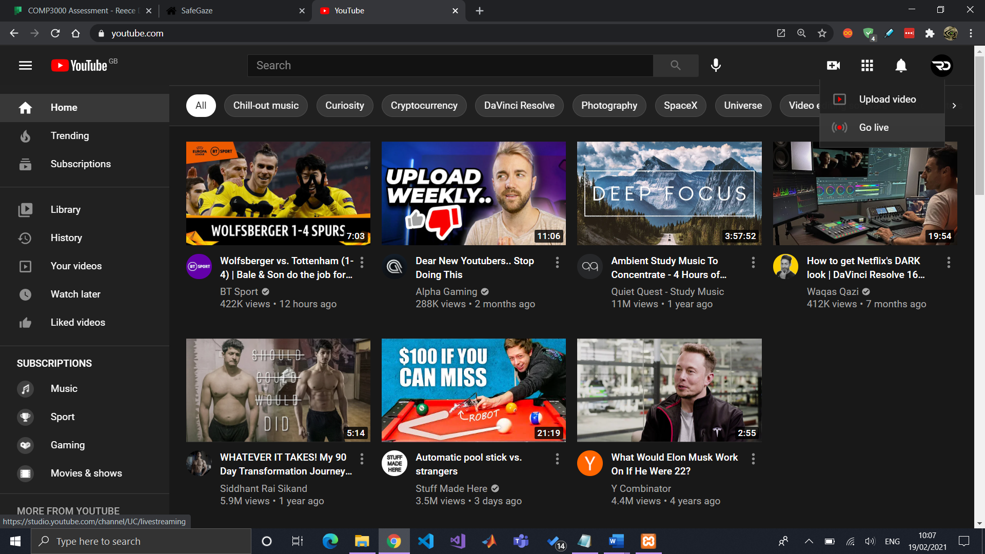 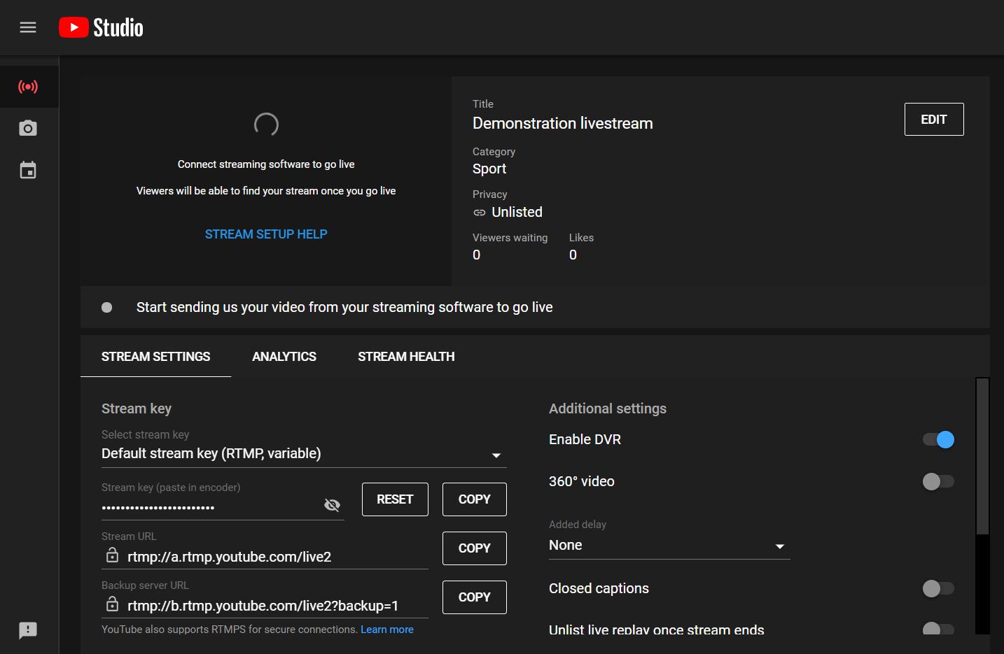

To capture video through a DSLR camera, or something similar, and encode the footage to your computer, a “video capture card” is required, which is generally connected with a HDMI cable. Furthermore, OBS software is used to feed the footage directly to the YouTube stream. Getting this set up was particularly challenging as a lot of research was required to make it work with SafeGaze.

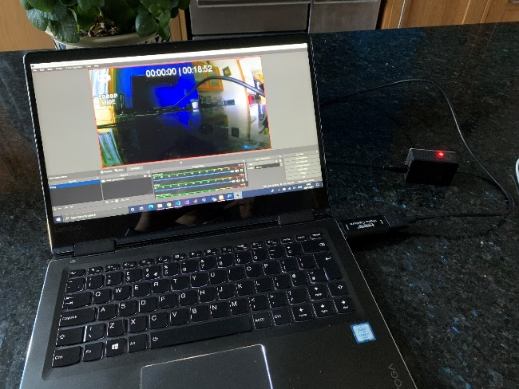

**Photo/video of OBS studio?**

## Linking livestream to SafeGaze

The next step is to link the YouTube livestream to SafeGaze. Click on “Share” within the YouTube livestream and copy the URL. Paste it into the “Create New Livestream” section in SafeGaze alongside with a title and optional livestream notes.

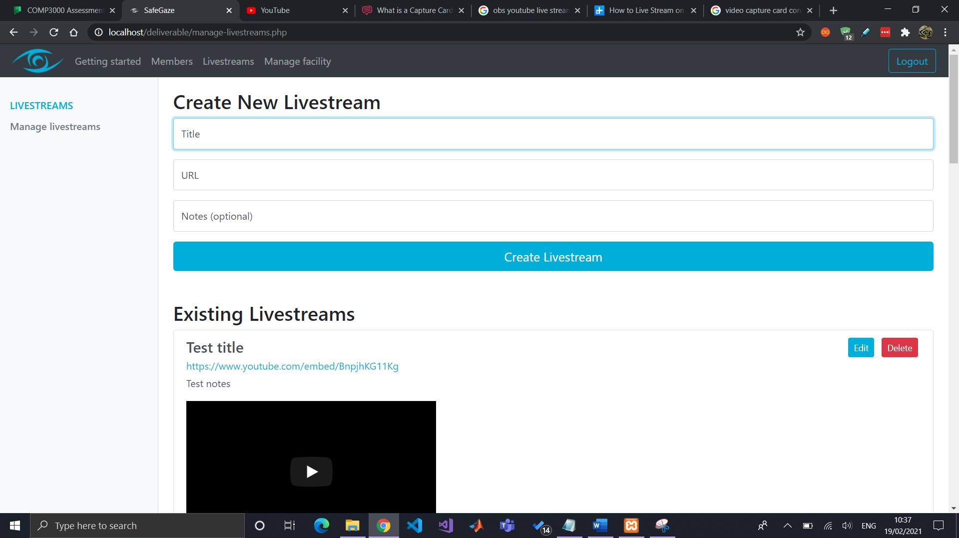

Upon submission, the livestream will now be available to the facility and its members.

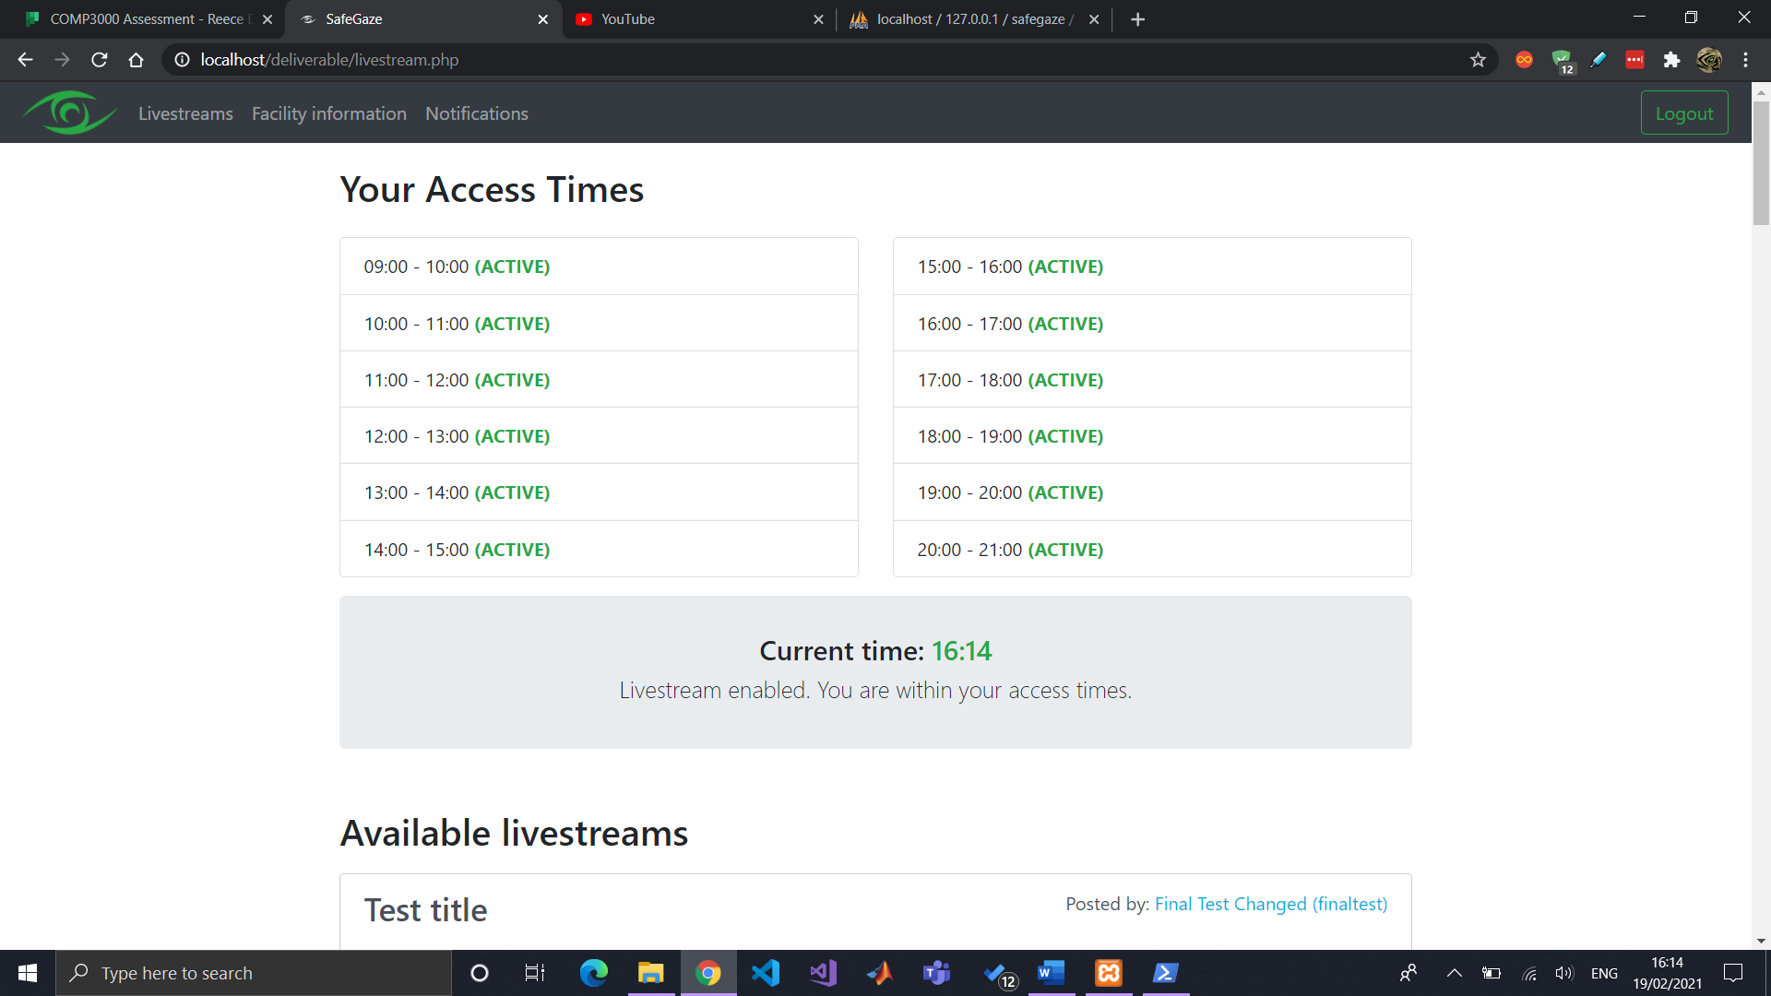 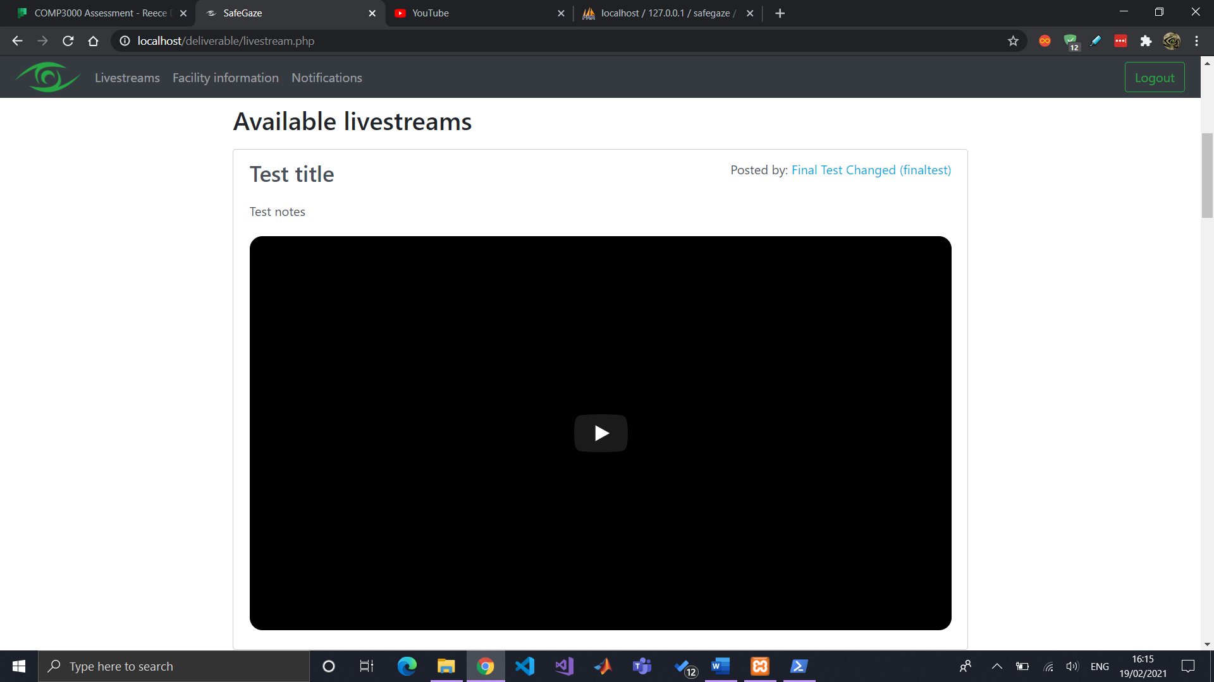

To delete a livestream or edit a livestream’s details, use the specified buttons available in the livestream List.

# Managing members

A member can sign up for a SafeGaze member’s account and link it with a facility with the use of their Facility Access Code, which is created when the facility signs up. Facilities can view their access code by navigation to the “Facility Information” section in the “Manage Facility” page.

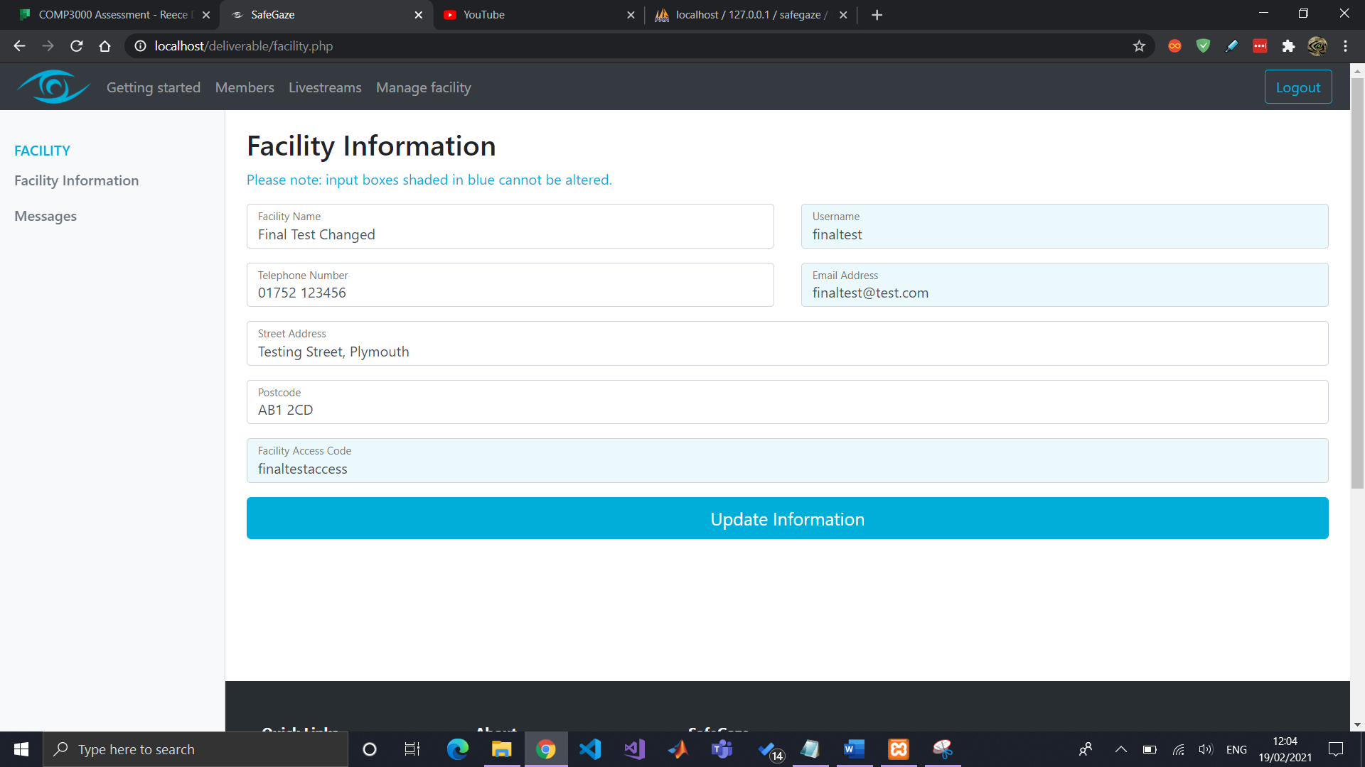

## Requests

When a member signs up, their account will be shown in “Member requests” and will remain pending until the facility either accepts or declines their account.

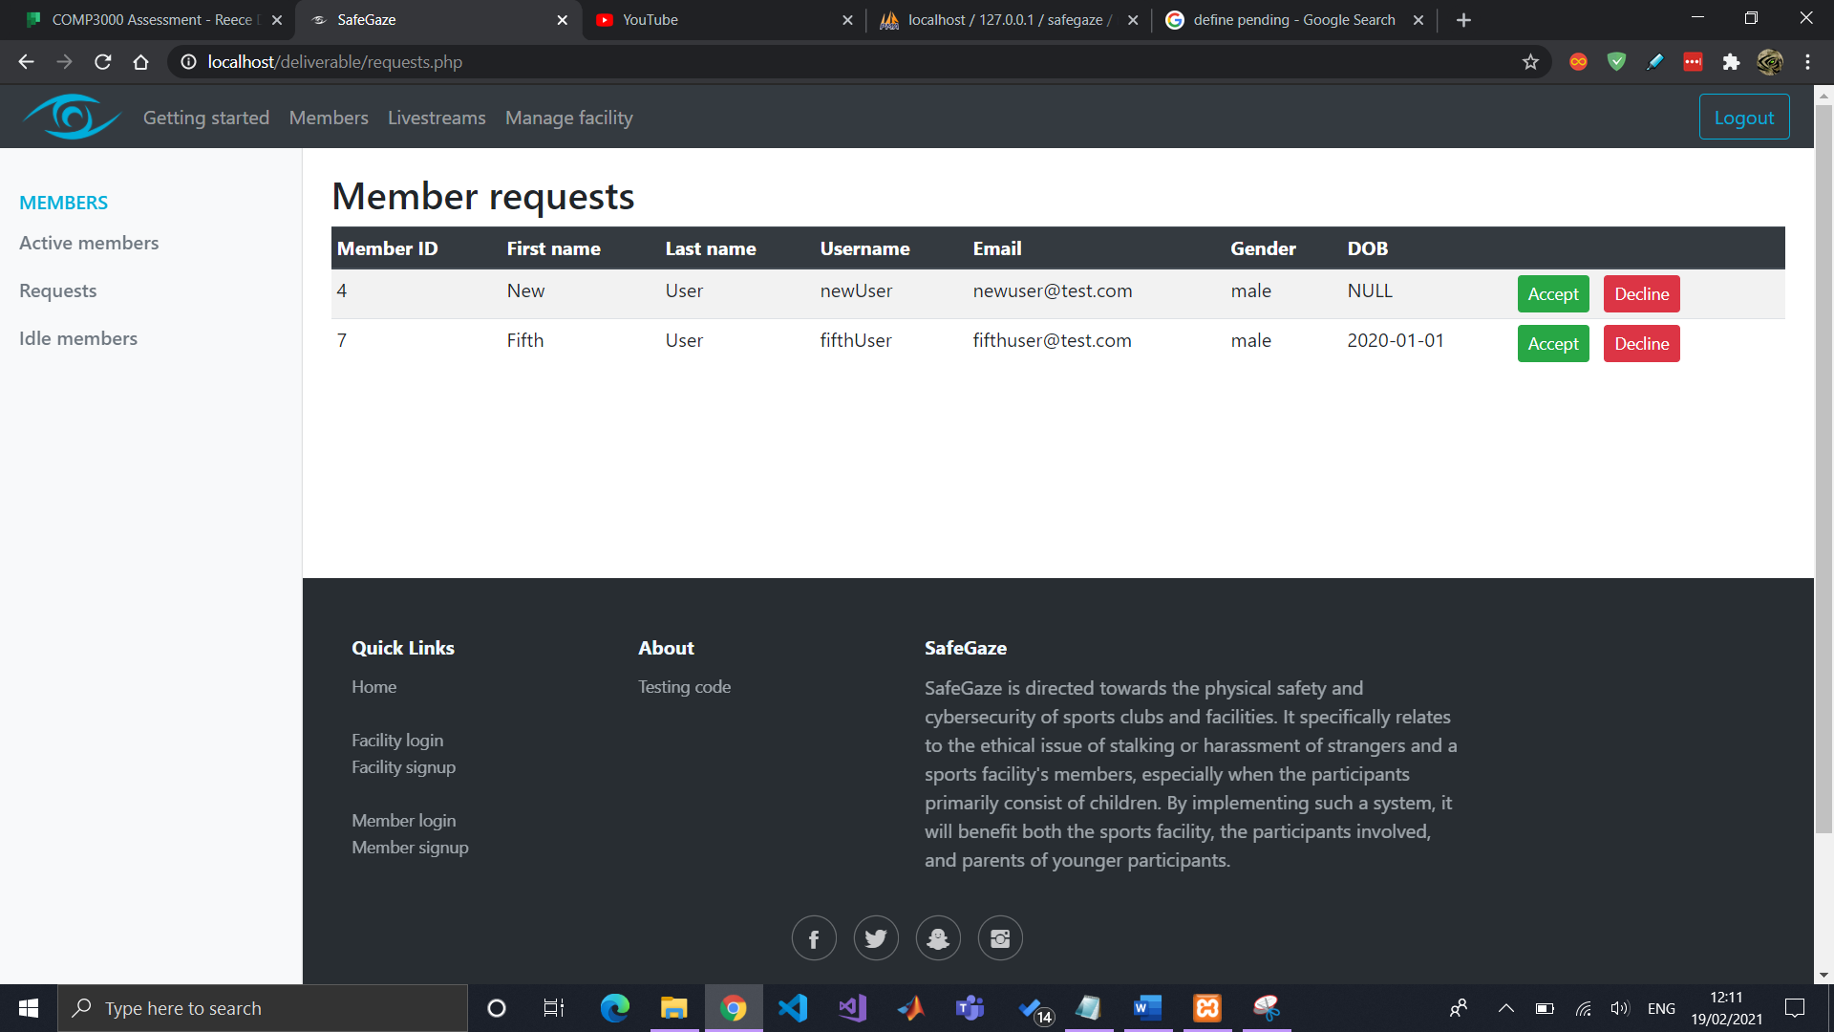 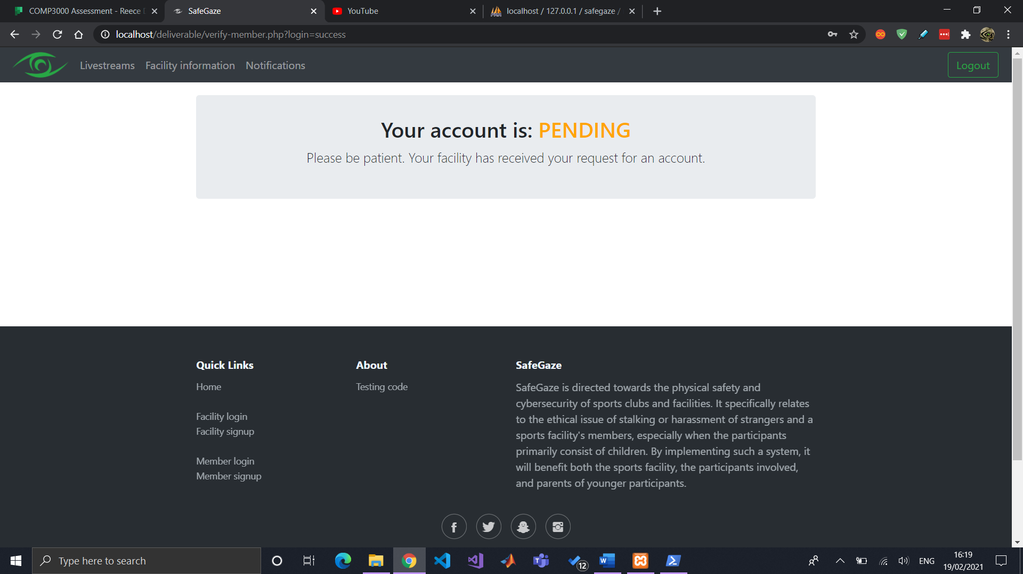

Upon hitting “Accept” they will then need to input what times the member will have access to the livestreams.

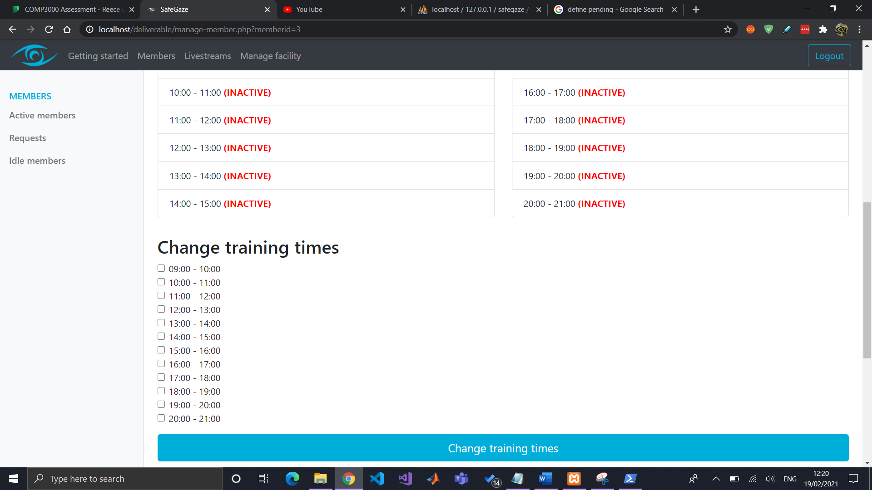

## Active members

All members that have access to a facility’s livestreams will be shown under “Active members”. The facility can change the member’s account’s status and livestream access times by clicking on the “Manage” button displayed to the right of each user.

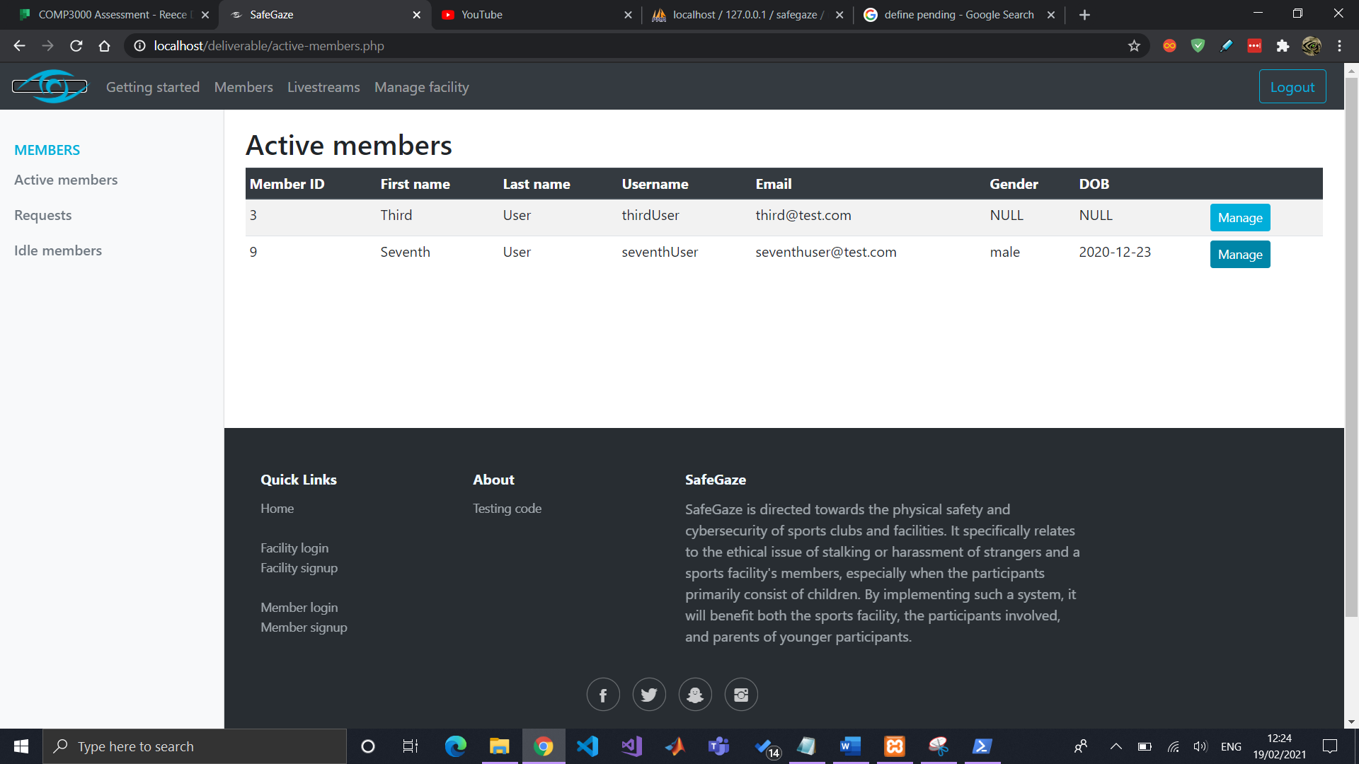 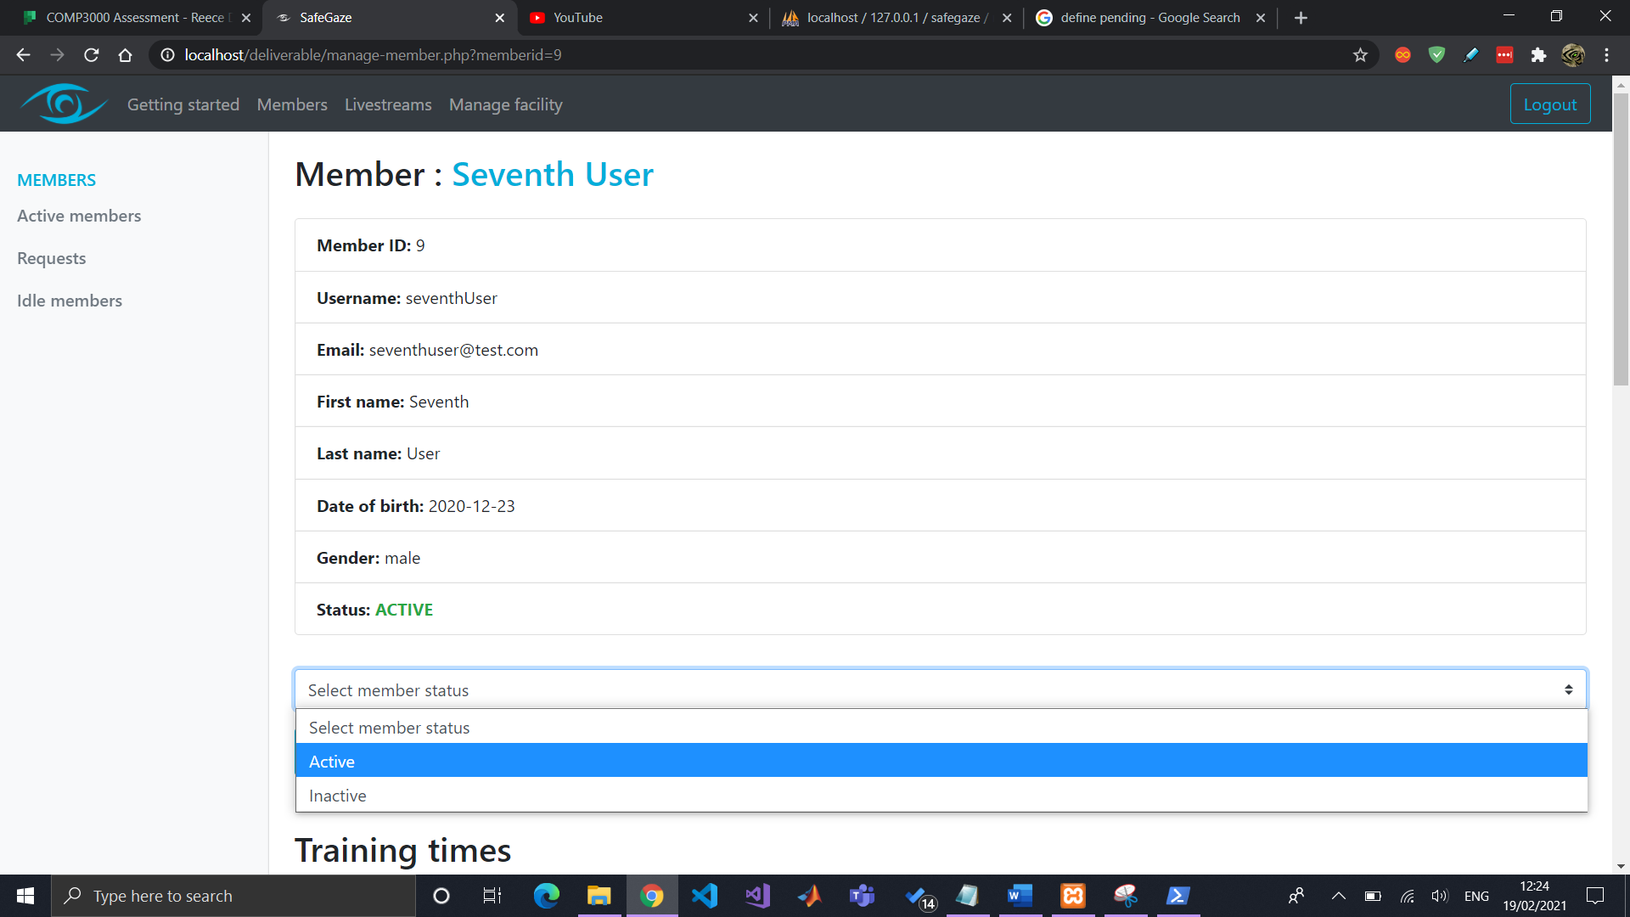 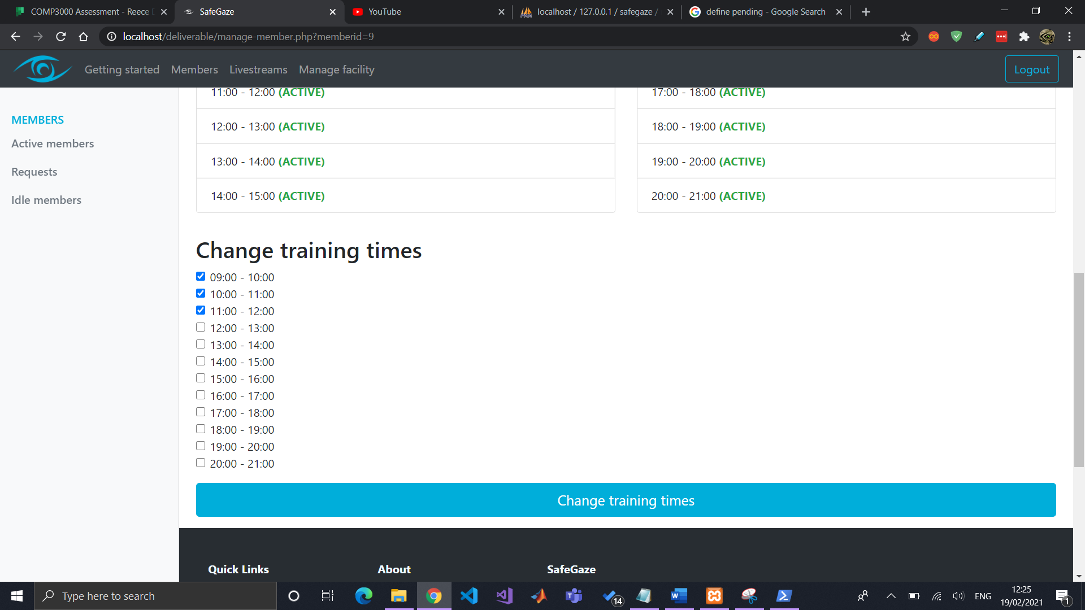

## Inactive/Declined members

Any members that have been declined or marked as “Inactive”, meaning their account has been disabled, will be listed in the “IDLE members” page.

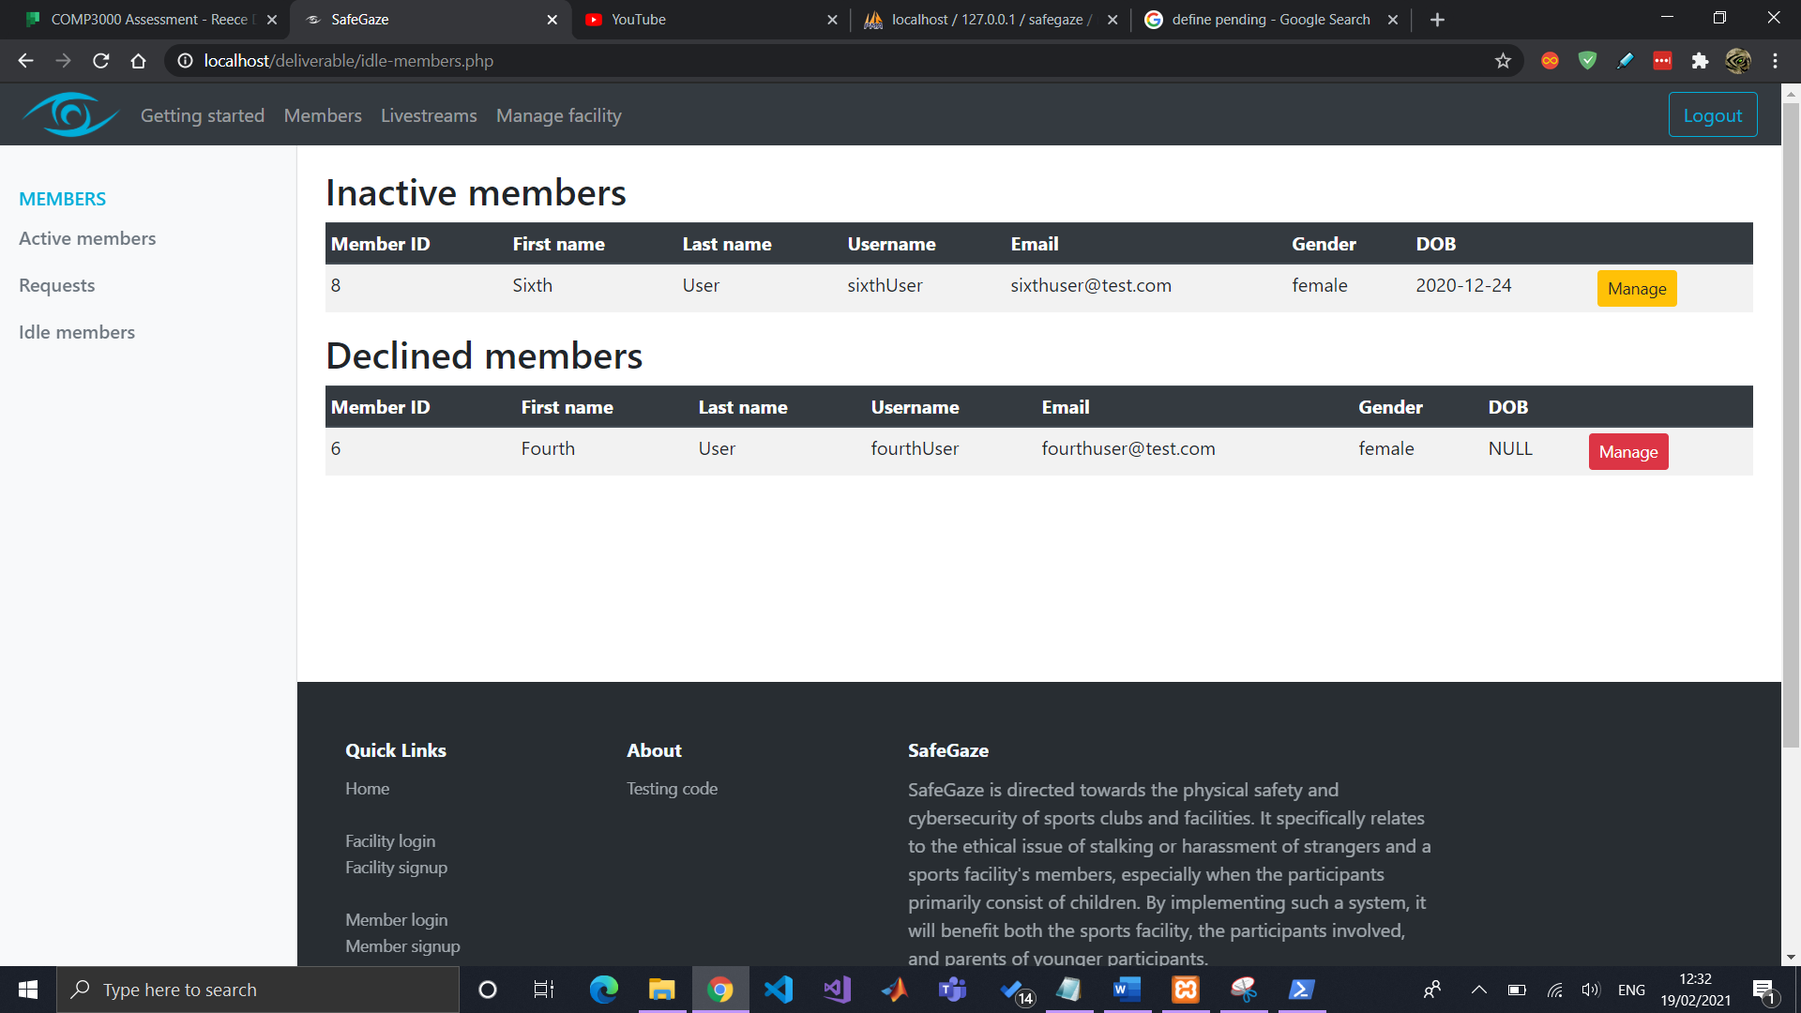 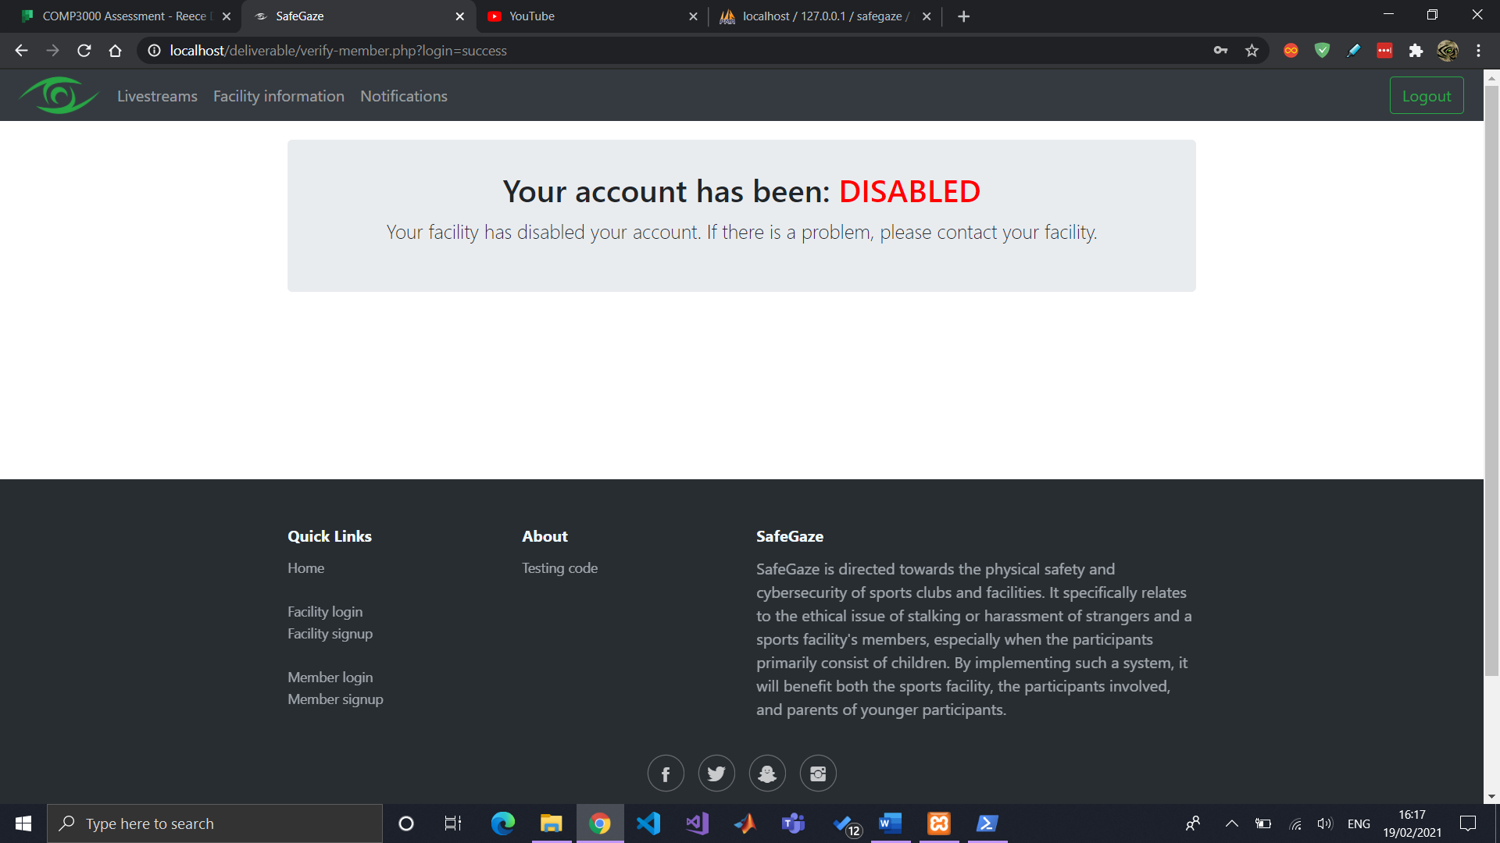 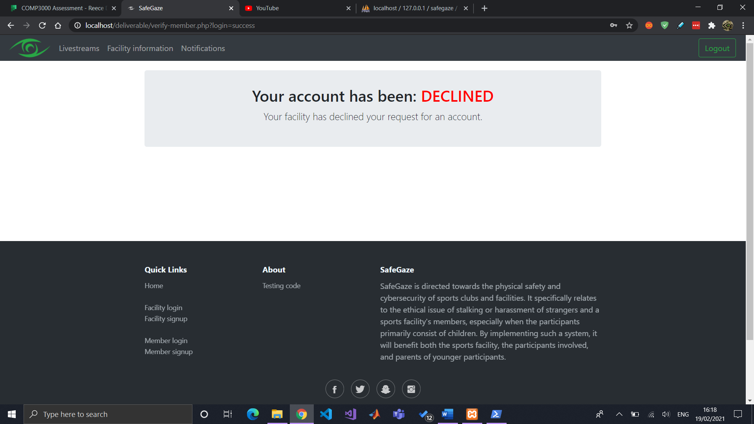

# Facility information

The facility’s information will be displayed to all active members, which primarily includes their contact information.

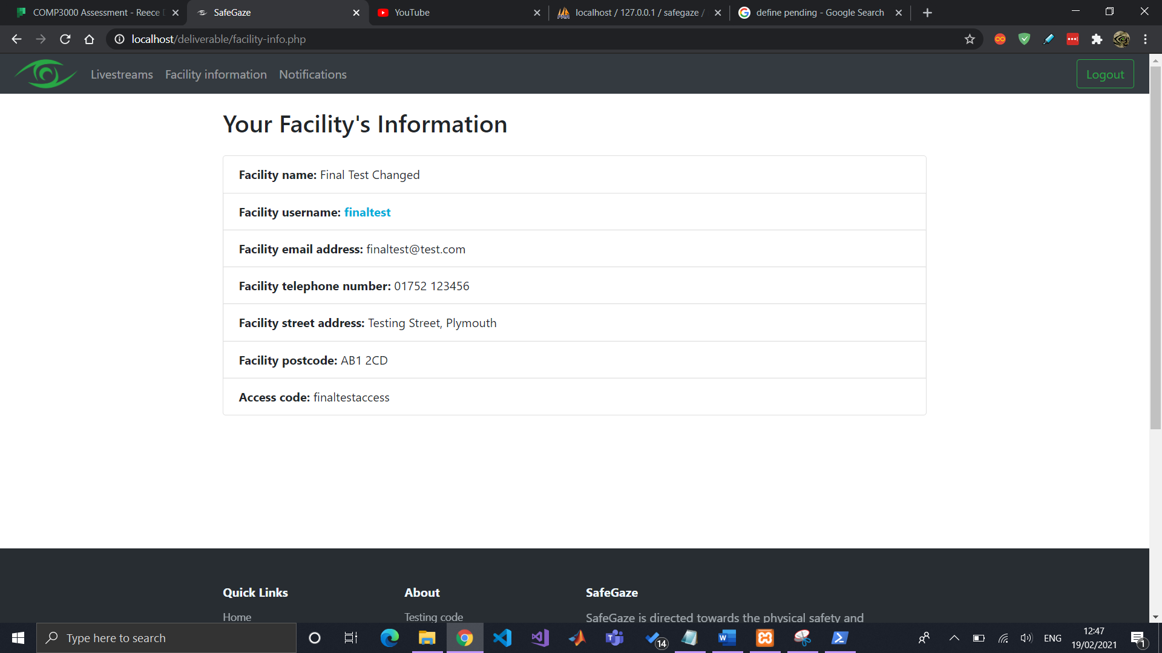

Some of these details can be changed by accessing “Facility Information” in the “Manage Facility” page.

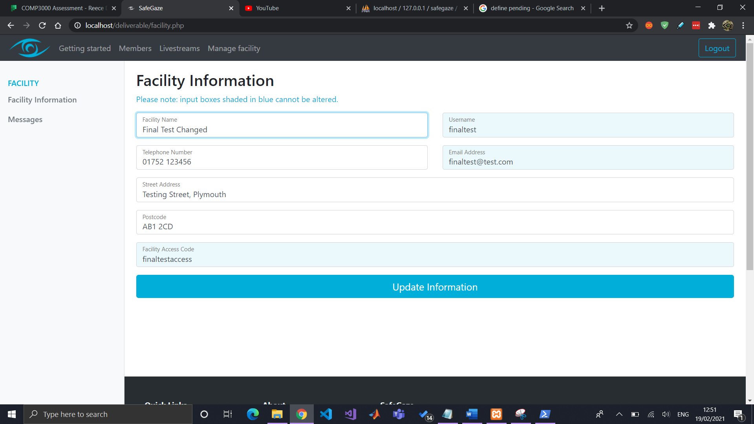

# Issuing messages

Lastly, facilities will be able to issue messages to all active members that have a SafeGaze account. By navigating to “Messages” in the “Manage facility” page, they can create new messages, as well as view a list of all existing messages.

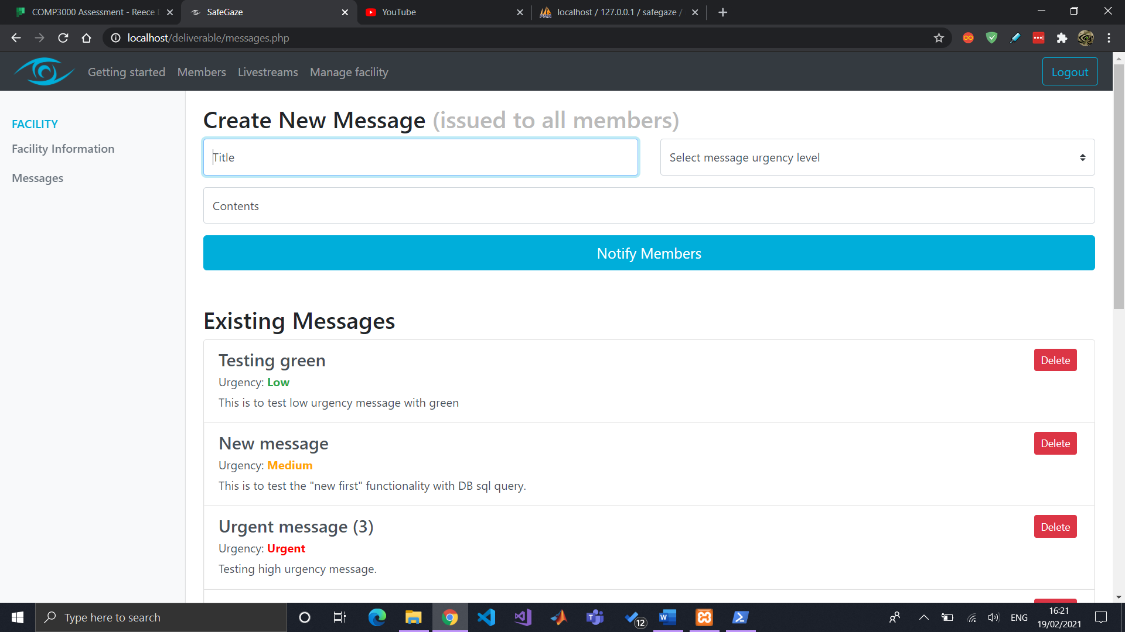 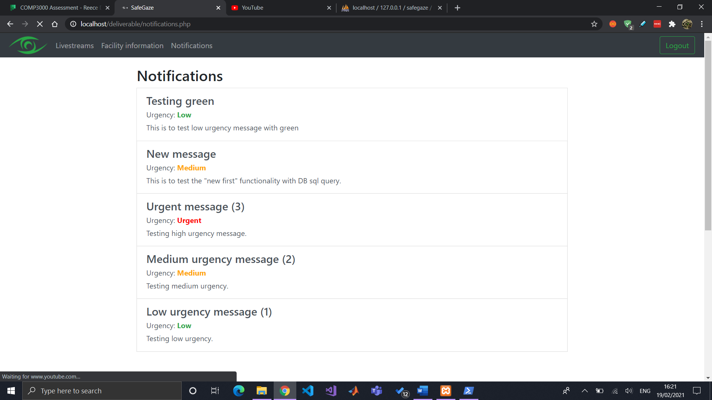Messages are marked with an “urgency level”, which can be useful in notifying members regarding important announcements.

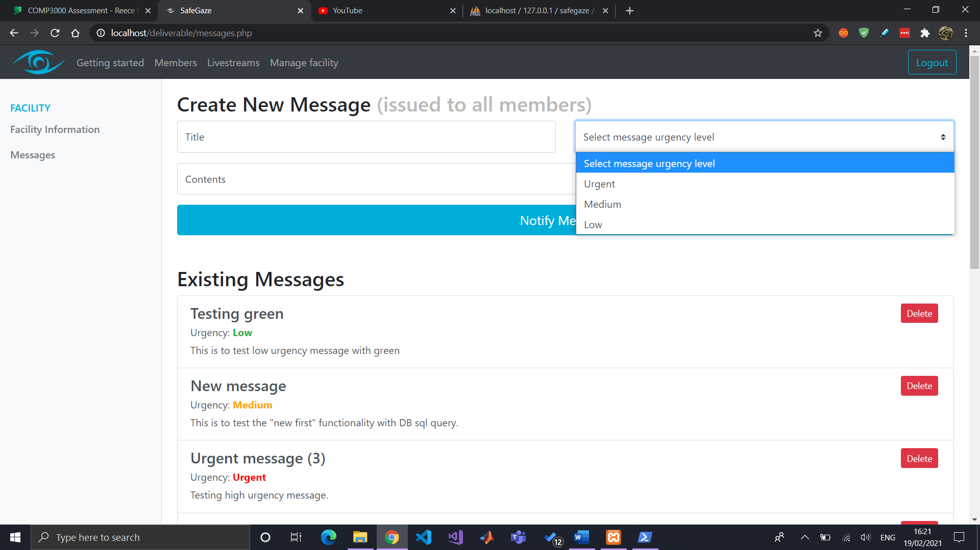

# A few additional notes

* Everything covered in this video can be found within the “Getting started” page which acts as documentation for facilities using SafeGaze.
* And the SafeGaze logo is an original piece that I created with the use of Photoshop.